Augmented Reality (AR) Folklore : The Potential of New Media for The Development of Malay Literature

ABSTRACT
The current era of digitization has led to a dynamic shift in the landscape of traditional materials and works in our country. This potential shift also applies to literary materials, particularly printed works and texts. Significant gaps exist in the process of utilizing new media in the development of literature. Studies related to the use of new media in expanding literature remain limited. Therefore, to address this gap, this study aims to explore the potential of a cutting-edge technology, namely augmented reality (AR), to be developed for folklore. The method of developing AR will use the ADDIE model, encompassing the creation process of the Awang Batil folk tale, "The Story of Awang and the Goat that Defecated Gold." The folk tale, developed using the AR application, will involve five development phases based on the ADDIE model. The outcome of this development will be assessed for usability using Liz Kolb's Triple-E framework (2011) and has found that the use of technology such as the AR application has great potential to make the folk tale more engaging. The usability assessment of this AR folk tale indicates that it attracts more audience interest. Additionally, the importance of integrating AR into folklore is that it can serve as a medium to pique the interest of the younger generation in these stories. Consequently, this study is significant as a factor in adapting folklore into new media forms, and it should be further expanded to ensure the preservation of this cultural heritage.

Keywords: Augmented Reality (AR), Folklore, Kisah Kambing Berak Terbit Emas, ADDIE, Triple- E Framework

INTRODUCTION
Technological advancement has presented new challenges to all sectors in establishing digital development as a new national landscape. To uphold the aspect of arts and the national heritage, the application of technology extends to the Malay literary works, particularly folktale. Traditionally, folktale was introduced orally, later developed into a printed medium, and now is being introduced in a digital form (Ahmad Fikri & Zamri, 2022; Mohd Effizan & Rosnidar, 2023). This development is in line with the initiatives in the western countries that have begun developing new mediums for folktales with the aim of promoting and preserving literary heritage from extinction (Loannakis, 2020). Likewise, neighbouring countries such as Singapore and Indonesia have upheld and promoted their literature through various technological applications such as e-comics, augmented reality (AR) and interactive multimedia, most of which play a crucial role in transforming audience engagement across different age groups. In fact, according to Allen (2014), as cited in Mohamed Nazreen Shahul and Muhammad Nur Saiful (2021), literary materials developed in digital application form have become a significant alternative to conventional media such as storybooks, epics, historical texts, and academic books. Augmented Reality (AR) is one of the most recent technological applications which has gained popularity worldwide. Nezhyva et al. (2021) stated that the western countries have actively embarked on the use of AR in the field of education, including in topics such as science, medicine, and engineering, through the use of electronic devices to project realistic visual representations. The uniqueness of AR lies in the capability to deliver interactive experience that can enhance user engagement and enrich the learning process. In the context of literature, the development of new media such as AR has also begun to garner attention in Malaysia, although thorough and comprehensive studies remain limited. Previous studies, such as literary e-comics by Mohamed Nazreen Shahul and Muhammad Nur Saiful (2021), the digitisation of folktales by Mohd Effizan and Rosnidar (2023), and the study of literary audiobooks by Rosmani (2019), emphasises the need for the development of new media and technological applications suitable for the literary field. However, most of these studies remain largely textual in nature and have yet to fully harness the digital interactivity.
In view of this background, there remains a clear research gap in the context of Malay literature using new technology, particularly AR. While other countries have been benefitting from AR to enrich readers’ experiences and learning, studies in Malaysia that focus on the adaptation of folktale through AR remain limited. This indicates that the potential AR as an interactive tool to promote Malay literature has not been fully explored. Therefore, this study seeks to examine the potential use of Augmented Reality (AR) technology in the development and presentation of Malay folktale, in order to understand the extent to which this emerging technology can be employed to promote Malay literature in a digital context, while also offering preliminary insights for designing interactive applications that are relevant to local culture and values.

LITERATURE REVIEW
The latest technological advancement has open up vast opportunities for the development of literary materials through digital and interactive media. In this context, Augmented Reality (AR) has become one of the most promosing technologies because not only it allows literary texts presented in an engaging manner, but also offers allows readers to interact directly with stories and characters. A recent study by Pahlevi et al. (2024) titled Storybook berbasis Augmented Reality (AR) meningkatkan hasil belajar bahasa Inggeris siswa shows that the integration of AR in storybooks allows learners to access three-dimensional (3D) objects that can be manipulated and viewed from multiple angles, thereby enriching their learning experience. Conducted through a quasi-experimental design comparing students’ performance before and after the use of AR, the study found significant improvements in learners’ motivation, engagement, and comprehension in contrast to conventional learning methods.
In line with that, a study by Reselly Elfa Putri and Fikry Prasetya Syahputra (2023) developed an application called Ngelmu, which incorporates Augmented Reality (AR) with game-based learning for the teaching of Panji stories at the primary school level. This descriptive-analytical study indicated that students were more engaged with the lesson content when interactive elements such as AR and gameplay were integrated. The findings indicate that AR not only enhances the learning experience but also has a positive impact on students’ interest and motivation in understanding folktales. Novia et al. (2023) emphasized that AR-based storybooks have the potential to shape the reading abilities of modern children and to foster greater interaction with the text. Collectively, these studies suggest that AR is not merely an auxiliary visual medium, but a pedagogical tool capable of concurrently enhancing students’ cognitive, affective, and motivational dimensions.
Previous studies such as those by Titiana, Dewi & Maranatha (2022) and Putra et al. (2022) further strengthen these findings, emphasizing that the use of AR storybooks can improve students’ knowledge, skills, and engagement in learning. These studies highlight that AR media offers a more immersive experience compared to traditional media, whereby students not only read the text but also interact with characters, settings, and dynamic story elements. In other words, AR adds an additional dimension that brings literature to life and makes it more relevant to the current generation accustomed to digital technology.
At the international level, Nezhyva et al. (2021) developed AR as the primary learning tool at schools across Ukraine, particularly in the teaching of folktale. The study found that AR could elevate students’ emotional engagement with characters, episodes, and the text itself. This emphasis on emotion and interaction indicates that AR is effective not only from a cognitive standpoint but also in influencing readers’ affective experiences, therefore improving their memory retention and comprehension of the text. Prasetya and Anistrasari (2020), on the other hand, highlighted that the use of AR in learning can increase students’ motivation and memory, further reinforcing the conclusion that AR has a positive pedagogical impact.
Although the development of AR and this new media is growing rapidly at the international level, the development of AR in literature remains limited in Malaysia. A study by Mohd Effizan & Rosnidar (2023) dan Ahmad Fikri & Zamri (2021) reveals that technological research in Malaysia predominantly concentrate in the fields of science, technology, mathematics and engineering. The literature development based on digital technology remains rare, and the existing studies are mostly in textual and analytic qualitative in nature. A study by Mohamed Nazreen Shahul & Muhammad Nur Saiful (2021) on e-comics Hikayat Patani highlights the potential of new media to attract readers’ interest; however, the number of local studies remains small. This circumstance clearly reveals a significant research gap — the use of AR and digital media for the development of traditional literature in Malaysia has yet to be fully explored.
Apart from AR, a number of studies emphasize the importance of the ADDIE instructional design model in the development of interactive learning applications. A study by Muhammad Syukri & Roznim (2021), Noor Fadzilah et al. (2021), Logambigai et al. (2022), dan Sa’adiah et al. (2020) reveal that ADDIE model provides a systematic guidance for the design, development, implementation, and evaluation of learning applications. The adaptation of this model in the development of AR-based folktale applications is crucial to ensure that the prototype produced possesses high levels of validity, effectiveness, and usability. The ADDIE model allows researchers to ensure that each interactive element—such as text, audio, animation, and graphics—is systematically organized to deliver an optimal learning experience.
Overall, this literature review highlights Augmented Reality (AR) and other digital media hold significant potential in the development of literature, yielding positive impacts on readers’ motivation, engagement, and comprehension. Nevertheless, in Malaysia, the application of such technologies remains largely confined to textual rather than interactive studies. Therefore, this study aims to explore the potential use of AR in the Malay folktale Kisah Awang dan Kambing Berak Terbit Emas, while adopting the ADDIE model as the foundation for developing an interactive application relevant to the local context. This study not only seeks to address the existing research gap but also provides insights into how AR can be effectively adapted for the teaching and learning of traditional literature

THE EVOLUTION OF AUGMENTED REALITY (AR)
A technology known as augmented reality (AR) combines virtual things with the physical environment into a single display. Overlaying computer-generated visuals on top of real-world content allows for this merging process. It is believed that Sutherland's (1968) work on a 3D visual system using a see-through head-mounted display marked the beginning of the development of augmented reality in the 1960s. When working for Boeing Computer Services in 1990, Caudell used the term "augmented reality" for the first time (Carmigniani et al., 2011). With Azuma's 1997 survey of AR research, the field's growth as a research area got underway in the 1990s. With multiple international symposiums devoted to the subject, it has now developed into a prominent field of technological research (Azuma et al., 2001). Several criteria for defining AR development have been established, as illustrated in Figure 1.

Combines real objects with virtual in real environments

Functioning interactively in real-time with one another

Augmented Reality

Real object rows with virtual between each other

Figure 1 : The description of Augmented Reality features according to Azuma et al.,2001

The use of augmented reality is growing in various domains, including education. This application can be used for teaching and learning, thanks to a new paradigm in augmented reality. Kaggal Lakshamana (2022) conducted a literature review for his dissertation, "Smart Mobile Augmented Reality For Orthodontics Teaching and Learning Environment," highlighting the development of augmented reality to mobile augmented reality (MAR). He outlined the MAR application to serve the public, professionals, and students' needs. Its use for tourism (Wedyen et al., 2016), entertainment and advertising (Panayiotou, 2016), and a widening range of educational applications marked the beginning of its development. (Chen and colleagues, 2017). The emphasis on research through his writing has also made it clear that MAR makes teaching and learning pedagogy more engaging and interactive.
The use of AR continues to evolve in various forms for teaching literary works, particularly aimed at children's reading. This marks the beginning of AR integration into the field of literature, with reading materials being presented in 3D reality displays to capture readers' interest. This development can be observed in AR applications in children's reading materials, such as the "Hippo Magic Book" for English vocabulary and the AR demonstration in the publication "Kobzar’s Alphabet," as shown in Figures 2 and 3.

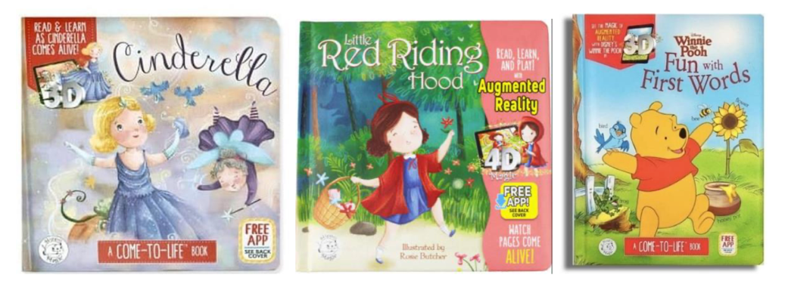

Figure 2. Educational materials using Mobile Augmented Reality (AR)
Source: AR Storybook "Hippo Magic Book" in the writing by ES Titiana, F Dewi, and JR Maranagtha (2023)

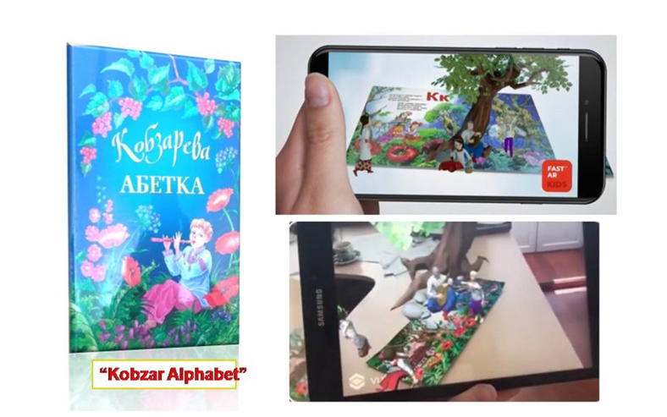

Figure 3. AR demonstration in the publication "Kobzar’s Alphabet"
Source: Nezhyva et al. (2020), "Augmented Reality in the Literary Education of Primary School Children: Specifics, Creation".

Developing these technological application materials requires usability evaluation to ensure their significance for end users. Numerous models can be employed to evaluate interactive multimedia materials. Among the theories and models available are the Unified Theory of Acceptance and Use of Technology (UTAUT) by Venkatesh, Morris, Davis, and Davis (2003), the Technology Acceptance Model (TAM) by Davis (1986), the Triple-E Framework by Liz Kolb (2011), and the Pedagogical Usability Model by Norkelainen (2006). This study employs the Triple-E Model as the basis for evaluating AR folklores, as it is highly suitable for assessing developed technological applications.
Many prior studies that evaluated usability using the Triple-E Model lend credence to this technique. Pratama's (2022) study, "Viewing Technology Integration in Current Classroom Through Triple-E Framework," is one example. According to that study, the Triple-E framework offers a number of benefits when doing analysis. According to Gaer & Reyes (2022), the Triple-E application's primary goal is to ensure that the produced technology promotes student involvement and expands and enriches learning objectives. Sheila Erin Schatzke's doctoral dissertation in 2019, "A Validation Study of the Triple-E Rubric for Lesson Design: A Measurement Tool for Technology Use in the Classroom," from the University of North Texas, highlights the value of the Triple-E Framework in assessing AR usability. According to Schatzke (2019), the Triple-E framework has the potential to guide teachers in successfully planning lessons with appropriate technological tools. This framework has been validated and supported by the International Society for Technology in Education (ISTE), known for its best practices in integrating technology into teaching and learning.
Liz Kolb, in her 2017 publication "Learning First, Technology Second: The Educator's Guide to Designing Authentic Lessons," fully supports the role of teachers in creating competitive learning opportunities facilitated by technological tools. The Triple-E Framework she developed not only enhances the effectiveness of educational pedagogy but also adds significant value by shaping technological tools in the form of models, modules, instruments, and applications that aid in planning effective teaching. The Triple-E Framework was designed to bridge the gap between educational technology use and classroom teaching practices. The components of Triple-E are constructed to help educators assess technological tools that have the potential to meet teaching and learning objectives. The evaluation rubric consists of three components: (i) evaluating student engagement, (ii) enhancing the learning goal, and (iii) extending the learning goals. The components of the Triple-E Framework are depicted in Figure 4 below. The questions provided in the rubric help evaluate the AR folklore application and assess the learning experience of the folklore through the positive impact of its potential use, understanding, and student engagement.

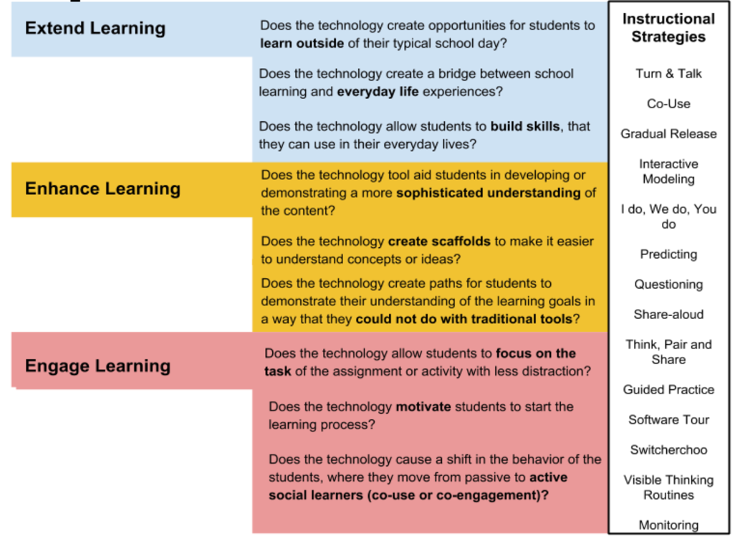

Figure 4. Triple-E Framework by Liz Kolb (2017)
Sumber : https://www.tripleeframework.com/framework-models.html

RESEARCH OBJECTIVE
This study aims to explore the potential use of Augmented Reality (AR) technology in the development and delivery of Malay folktale, focusing on understanding the extent to which AR can serve as an interactive medium that promotes Malay literature in the digital context, while providing preliminary guidelines for the development of interactive applications aligned with local culture and values

METHODOLOGY
The framework for developing the AR application for the folklore "Kisah Awang dan Kambing Berak Terbit Emas" is based on the ADDIE design model. The significance of selecting this model, as cited by Manan et al. (2010) in Sa’adiah et al. (2020), lies in its clear and straightforward structure, making it appropriate for developing technological applications. The framework depicted in Figure 5 below illustrates the development methodology for the AR folklore, which involves five phases:
Analysis Phase

Design Phase
Evaluation Phase

Development Phase

Implementation Phase

Figure 5 : The Development Phase of AR Folklore Adapted Sa’adiah et al.,(2021)

Given the objectives of this study, which aim to explore the potential use of Augmented Reality (AR) in the development of folktales as a new medium for advancing Malay literature, the prototype development phase was carried out based on the ADDIE model. The first phase involved data collection for needs analysis, conducted through two main approaches: a literature review and semi-structured interviews with six experts in the field of literature.
The selection of six experts as informants in this study employed purposive sampling, based on the rationale that each informant was chosen for their expertise, experience, and relevance in the field of Malay literature. This method aligns with the nature of qualitative research, which emphasizes data quality, analytical depth, and the informants’ capacity to generate rich information, rather than aiming for population generalization (Patton, 1990; Palinkas et al., 2015). Previous studies have shown that in qualitative approaches, a small sample size is appropriate when the primary focus is on case-oriented analysis and the selection of information-rich informants (Vasileiou et al., 2018). In other words, this study does not seek to generalize to a broader population but rather to obtain in-depth insights and critical analyses from individuals with substantial knowledge in the field.
The selected sample consists of a homogeneous group. This approach is justified as this group can provide rich data with diverse perspectives and more accurate responses due to their similar backgrounds and experiences (Merriam, 2009; Adler & Ziglio, 1996). The selected sample included experienced teachers and experts. Berliner (2004a, 2004b) states that teachers are considered experts if they have been teaching for at least five years. According to Gambatese et al. (2008), academicians can become experts in their field of interest. As a result, the respondents in this study were teachers who had been teaching Communicative Malay Literature for at least five years. The respondents' demographic information is shown in Table 1.
Table 1. The Profile of Expert Interview Respondents in the Needs Analysis Phase
No | Name | Age | Gender | Teaching experience | Experience in Literature | Education Level
1 | G1 | 58 | P | 27 years | 22 years | Master’s
2 | G2 | 48 | P | 28 years | 18 years | Master’s
3 | G3 | 47 | P | 18 years | 15 years | Doctorate
4 | G4 | 52 | L | 19 years | 18 years | Master’s
5 | G5 | 40 | L | 12 years | 6 years | Bachelor’s
6 | G6 | 43 | L | 15 years | 10 years | Master’s

Three reputable experts were appointed to review the interview transcripts conducted to ensure validity in terms of both language and content. A pilot study of the interviews was also conducted with respondents possessing similar characteristics to the actual respondents. This pilot study aimed to refine questions for enhanced information retrieval and estimate time constraints for each respondent during the interviews (Ahmad Fikri et al., 2022). Following the actual interviews, transcripts will be completed and returned to respondents for verification. The thematic analysis of interviews will involve coding each participant's responses. Data from the interviews will be classified, subcategorized, and analyzed using coding methods to generate themes (Huberman & Miles, 2012). The questions posed to the respondents aim to gather data on the need for new media in teaching Malay literatur.
In the design and development phase, the data collection method employed was a field study aimed at obtaining a folklore from Awang Batil, specifically involving informant En Ramli bin Mahmud. The field study was conducted with the objective of acquiring an authentic folklore. Observation protocols were established, accompanied by the preparation of video and audio recording equipment to facilitate the recording process and observation procedures. The significance of this field study lies in exploring the potential of traditional folklores to be developed into new media formats. Three experts will be engaged to validate the design and prototype of the AR (Augmented Reality) folklore developed using the Assemblrworld application.
The implementation and evaluation phase will utilize a checklist in the form of a rubric with eleven students majoring in Malay literature from public schools and universities. The rationale for selecting students from literature disciplines is to assess the potential of AR among future end-users. The checklist used adheres to the Tripple-E framework developed by Kolb (2017). This phase of implementation and evaluation aims to examine the potential of AR in its third phase using manual methods of analysis. The relatively small sample size focuses solely on direct potential without evaluating the effectiveness of AR. The following table presents the interpretation schedule developed by Liz Kolb (2017) for analyzing usability assessments of tools and technology applications.

Table 2. Liz Kolb’s Interpretation (2011)
Score | Interpretation
13 -18 | Excellent usability of the technology application (Exceptional connection between learning goals and tool)
7-12 | Moderate usability of the technology application with some connection to learning goals (some connection between learning goals and tool)
Below 6 | Very low usability of the technology application (Low connection between learning goals and tool)

FINDINGS AND DISCUSSION
The findings of this study indicate that the integration of new media such as Augmented Reality (AR) is highly necessary in the development of teaching and learning materials. Digital and interactive resources demonstrate strong potential to support the teaching and learning process and develop literature. The needs analysis, conducted through semi-structured interviews with experts and analysed using NVivo, identified several key factors emphasizing the significance of developing AR-based teaching aids within the context of literary education, as illustrated in Figure 4.
Lack of Reference Materials
Issues of the learning aspect
Student role

Values and Morals in Folklore
Impact of the General Public
AR Folklore Application
Impact on education aspect

The advantegs of AR
AR Opportunties in Literature

The advantages of Educational AR

Figure 4: Thematic Analysis of the Need for Augmented Reality (AR) Folklore Development
The outcomes of the semi-structured interview analysis conducted with six Malay literature experts revealed three main themes that are fundamental factors driving the need for the development of an Augmented Reality (AR) application for folklore. The three themes are (1) issues in literary learning, (2) the moral and value-laden content of folklore, and (3) the capabilities of technology (AR) in enriching literary delivery. These themes were derived through a coding process using NVivo software and supported by triangulating findings from previous literature.
The majority of informants (G1 to G5) indicated that the main issues in learning literature stem from the limited availability of reference materials and students’ low level of interest in folk literature. The scarcity of contemporary and engaging resources, coupled with the predominantly traditional modes of presentation, makes it difficult for students to fully grasp and appreciate the underlying values of these literary works. This circumstance ultimately affects the effectiveness of literature teaching and learning (T&L) in the classroom. The following excerpts from the interviews further illustrate this issue:

"...folklores that are cultural heritage but what I see here is that in terms of materials, they are still lacking especially in terms of books and this also burdens the students. ...the materials used to convey folk literature are still insufficient." (Informant G4)
So what I think is that folk literature, um, in schools should have more materials so that students have more options, um, to continue learning this folk literature. (Informant G5)
If we ask these students whether they know about folk literature at all, they won't know. They are lazy to read and not interested in reading literary works. They really do not know what folk literature is. (Informant G1).
The findings indicate that the conventional modes of delivering folk literature are no longer effective in capturing the attention of the younger generation, who are more attuned to the digital world. This aligns with the findings of Yulianti et al. (2019) and Pahlevi et al. (2024), who emphasised that literary materials should be adapted into interactive media formats to increase students’ interest and engagement. In the Malaysian teaching and learning context, Mohd Effizan and Rosnidar (2023) also found that the digitalisation of folk literature can help rekindle students’ diminishing interest in literature. Therefore, these findings address the need to develop new media, such as Augmented Reality (AR), to enhance the effectiveness of literature teaching and learning.
The second theme identified is the value and moral content embedded in folklore, which is considered still relevant for application in contemporary society. All informants (particularly GB3 and GB4) stated that folklore contains numerous important values and lessons, serving not only as a cultural heritage but also as a source of moral education and character building among students. The following interview excerpts support this view:

"The values found in Malay literature can be used as guidelines especially in family life, with children, and later with the local community." (Informant G3)
"The local community can use literary sources as references for life." (Informant G4)
This finding aligns with the findings of Nezhyva et al. (2021) and Prasetya & Anistrasari (2020), who found that AR applications in education can help students understand moral values more deeply through through interactive learning experiences and reality-based visualisation. In the context of Malay literature, values such as respect, love, courage, and wisdom that are inherent in folklore can be conveyed more effectively when combined with visual technology and interactive narratives.
In addition, these findings are consistent with Rosmani (2019), who emphasises that technologies such as audiobooks and interactive multimedia have the potential to revitalise traditional literary, making it more accessible to the modern readers. Therefore, the rich moral and value-oriented content embedded in folklore serves as a key justification for developing AR as a new medium for delivering literature.
The third theme identified is the capabilities of modern technology, particularly AR, in enhancing the delivery of literature. Most informants (G2, G3, and G6) noted that the younger generation is now highly exposed to technological devices such as smartphones, tablets, and laptops. Consequently, the presentation of literary works must adapt to the evolving learning patterns and preferences of this digital-native generation. The following excerpts from the interviews reflect this perspective:
"...considering the era, today's students are different from our time, where we didn't have technological devices..." (Informant G3)
"...the new generation is more exposed to the use of smartphones, tablets, and so forth, so they need to be exposed to more interactive and technological-based learning." (Informant G2)
"...students generally have an interest in interactive and engaging materials like games and applications." (Informant G6)
These findings reinforce the view that AR has strong potential as an interactive tool aligned with 21st-century learning practices. As highlighted by Allen (2014), as cited in Mohamed Nazreen Shahul and Muhammad Nur Saiful (2021), as well as by Nezhyva et al. (2021), AR technology not only increases student engagement but also enables learners to construct a more contextualised and meaningful understanding of the material. In the context of literature, AR allows for the integration of text, audio, and three-dimensional visuals, thereby bringing folk narratives to life in ways that are more immersive and accessible to students. Local studies, such as those by Mohd Effizan and Rosnidar (2023), further support this claim, demonstrating that technology-based approaches have significant potential to rekindle interest in folklore, particularly when these works are transformed into interactive digital formats.
Overall, the findings from the interview analysis and comparison with previous literature indicate that the development of AR for folklore is highly significant and relevant to current needs. The three main themes identified—issues in learning, value and moral content, and technological capabilities—provide a strong justification for the development of an AR-based application.
This study reinforces previous findings which indicate that the integration of technology into literary learning not only broadens access to educational materials but also serves as an important medium for the preservation and upholding of Malay cultural heritage in the digital age (Yulianti et al., 2019; Nezhyva et al., 2021; Pahlevi et al., 2024; Mohd Effizan & Rosnidar, 2023).
The findings from the design and development phase reveal the creation of a prototype for an AR folklore based on the story of Awang and the Golden Feces Goat. To produce an AR video of the folklore presented by Awang Batil, it will be transcribed into a written folklore text. This text will be categorized into several key events to form a complete storyboard, thereby facilitating the design of the AR folklore. The storyboard created resembles that depicted in Figure 5.

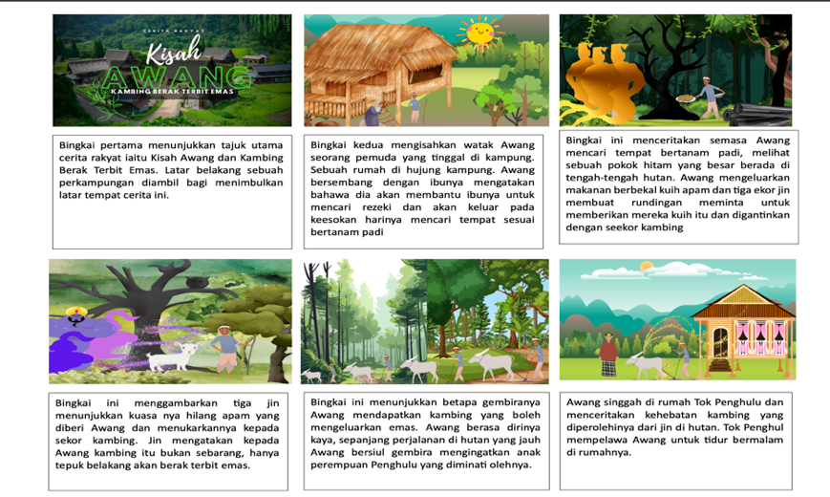

Diagram 5. Storyboard ("Kisah Awang dan Kambing Berak Terbit Emas")
The development of the AR design utilizes the Assemblrworld application downloaded from www.assemblrworld.com. This application is known for its user-friendly interface specifically designed for AR development purposes. An example of the AR development process applied to the folklore "Kisah Awang dan Kambing Berak Terbit Emas" is illustrated in Diagram 6 below
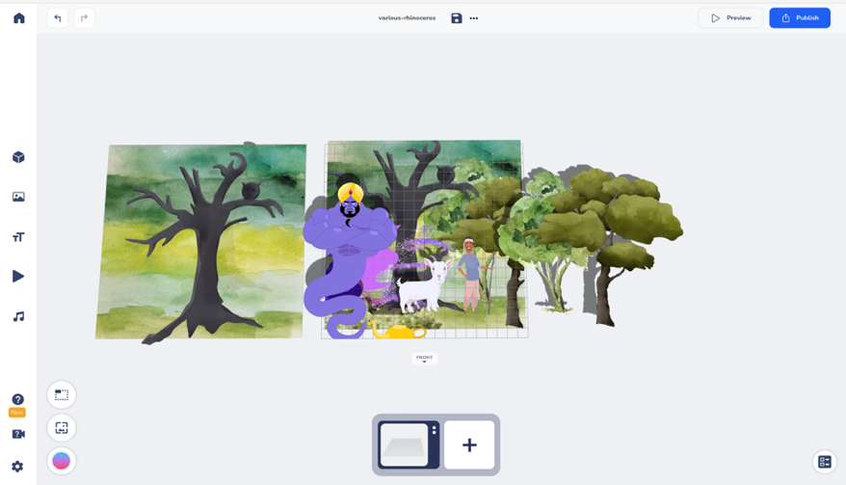

Diagram 6. The screenshot display of AR editing process using the Assemblrworld application.
The developed AR will be presented using a QR code scan as shown in Figure 6. This code will be scanned by students who wish to access this folklore AR using devices such as smartphones and tablets. Figure 6 provides an example display of the developed folklore AR.

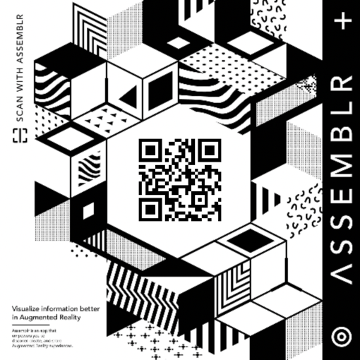
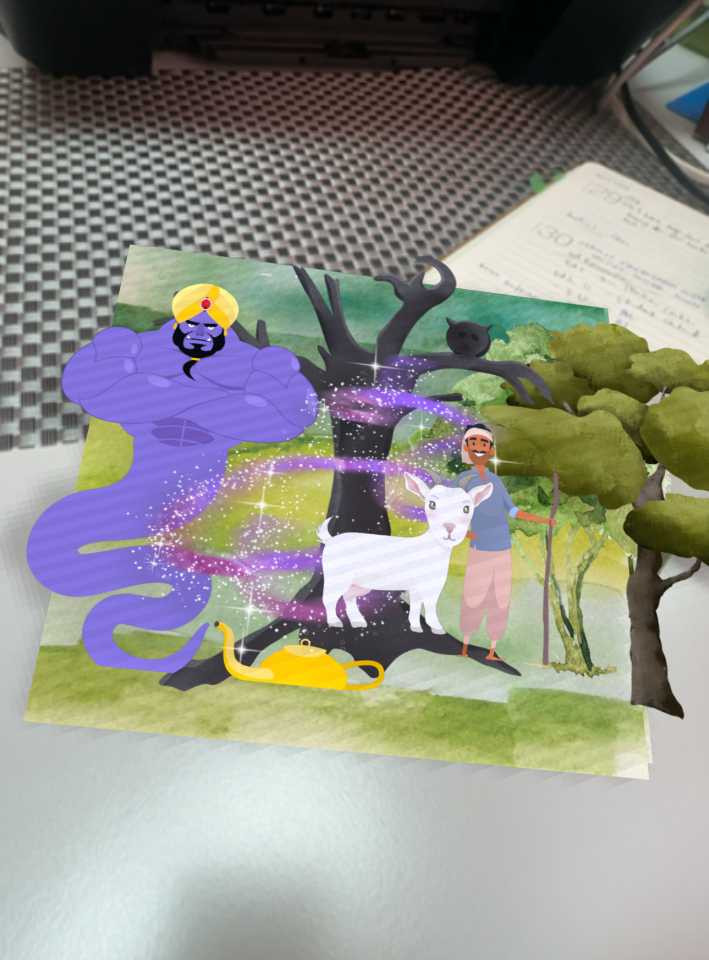

Figure 6. Display of Assemblr QR code scan and an example of 3D display using a smartphone.
Next, the findings for the implementation and evaluation phase are presented. Implementation was conducted with eleven study participants consisting of students enrolled in Malay Literature courses at various schools. All study participants were provided with a QR code scan along with an adapted checklist form developed based on Liz Kolb's Triple-E Framework (2017). The assessment results using this checklist are detailed in Table 2 below.
Table 2: Findings for the AR Folklore Assessment Phase
Evaluation Rubric |  | P1 | P2 | P3 | P4 | P5 | P6 | P7 | P8 | P9 | P10 | P11
Engagement of the Learning | Allow student focus | 2 | 2 | 1 | 2 | 2 | 2 | 2 | 2 | 2 | 2 | 2
Engagement of the Learning | Motivates students | 2 | 2 | 2 | 2 | 2 | 2 | 2 | 2 | 2 | 2 | 2
Engagement of the Learning | Passive to active students | 2 | 1 | 2 | 2 | 1 | 2 | 2 | 2 | 2 | 2 | 1
Enhancement of the learning goal | Sophisticated understanding | 2 | 2 | 2 | 2 | 2 | 2 | 2 | 2 | 2 | 2 | 2
Enhancement of the learning goal | Support concept and ideas | 2 | 2 | 2 | 2 | 2 | 2 | 2 | 2 | 2 | 2 | 2
Enhancement of the learning goal | Understanding learning goals | 2 | 1 | 2 | 2 | 1 | 2 | 2 | 2 | 2 | 1 | 1
Extending the learning goal | Create opportunity | 2 | 1 | 2 | 2 | 2 | 2 | 1 | 2 | 2 | 1 | 1
Extending the learning goal | real life experiences | 2 | 0 | 0 | 2 | 1 | 1 | 2 | 1 | 2 | 2 | 2
Extending the learning goal | Build authentic life soft skills | 1 | 1 | 2 | 2 | 1 | 2 | 1 | 2 | 2 | 1 | 2
 |  | 17 | 12 | 15 | 18 | 14 | 17 | 16 | 17 | 18 | 15 | 15

Each approval rating provided by the students follows the guidelines from Liz Kolb (2017). The values assigned in the manual calculation of the Triple E framework are as follows: (i) Strongly agree is valued at two points (2), (ii) agree is valued at one point (1), while (iii) disagree has a value of zero points (0). The score calculation for interpretation involves obtaining the average approval rating from the total number of samples (n) divided by the total assessment points in the rubric, which is eighteen. The formula for score calculation for interpretation is stated as follows
Σ
Average Score = Score (n1 + n2 + n3 + …)
18

Figure 7: Formula for Score Calculation in the Triple-E Framework Interpretation by Liz Kolb (2017)
Using the formula recommended by Liz Kolb (2017) within the Triple-E framework, the calculated score for the developed AR folklore project is 15.8 out of a total of 18.0 points. According to Kolb’s (2017) interpretation scale, a score range between 13 and 18 points indicates the highest level of usability and accessibility for a technological tool in education. This result suggests that the AR technology developed has strong potential.
The developed AR technology incorporates numerous effective teaching strategies. It shows significant engagement, effective learning practices, and opportunities for real-world application. A score exceeding 13 points indicates that all three components of the Triple-E framework are consistently met. Consequently, students are highly active in their learning tasks. Their understanding of the teaching objectives is enhanced in ways that conventional learning cannot achieve, ultimately extending their comprehension beyond the classroom sessions.
Students are able to relate their experiences using AR with what they have learned in their daily lives. More specifically, the findings on the usability evaluation of AR are detailed through the three components of the Triple-E framework as follows.

(i) Student Engagement
Findings from the eleven participants based on the Triple-E checklist indicate that the vast majority of students (90.9%) reported that the use of AR folklore materials helped them remain more focused during the learning process. All participants also strongly agreed that the application increased their motivation, while eight out of the eleven students (72.7%) reported that the incorporation of AR encouraged them to shift from being passive learners to more active ones.
Although the instructor was not directly involved in the learning activities, students remained motivated to engage with the folklore content because the realistic 3D visuals allowed them to experience the narrative more vividly. Students were able to rotate the images, explore characters and settings from multiple angles, and read the text of Kisah Awang dan Kambing Berak Terbit Emas in greater depth. This activity also demonstrated that students could access the AR learning materials without temporal or spatial limitations—not only in school, but also at home or in other locations. This indicates a clear shift from teacher-centred instruction to self-directed learning, in which students independently utilise devices such as smartphones and tablets to access the AR folklore content, while the instructor assumes the role of a facilitator who guides rather than leads the learning process
Overall, the findings on student engagement indicated that the use of AR-based folklore materials significantly improve students’ motivation, focus, and interest. Students reported feeling more interested and encouraged to interact with the learning materials due to the engaging visual and interactive features. These findings are consistent with Pahlevi et al. (2024), who found that AR storybooks enhance learner engagement in English language learning through dynamic and interactive 3D representations. Similarly, the study by Reselly Elfa Putri and Fikry Prasetya Syahputra (2023) demonstrated that the integration of AR with game-based learning in the Ngelmu application resulted in more active learners and a higher level of engagement. The alignment of these results with previous research reinforces the conclusion that AR is not merely a form of visual entertainment, but an effective pedagogical tool for increasing student engagement and motivation in understanding and appreciating folk literature.

(ii) Enhancement of the Learning Goal
The second set of findings focuses on how the use of the folklore AR application enhances the achievement of learning goals. The analysis indicates that all participants agreed that the AR application helped them understand the story content more deeply and provided a more sophisticated learning experience. Seven out of eleven participants (63.7 percent) reported that they were able to understand the learning objectives conveyed through the folklore AR application, while the remaining participants noted some difficulty in identifying the objectives clearly.
One of the factors contributing to the variation in students’ levels of understanding is the individual-centred nature of the AR implementation. The use of the application was not accompanied by group discussion activities or teacher-guided reflection sessions, resulting in fewer opportunities for students to exchange ideas or raise questions about the story content. It is anticipated that students’ comprehension levels would be higher if collaborative discussion activities were incorporated alongside the use of AR. In addition, some students did not own a smart device or had not downloaded the AssemblrWorld application, which prevented them from fully experiencing the AR reading activity.
Nevertheless, when analysed holistically, the findings indicate that the use of AR still contributes positively to the achievement of learning goals. AR enables students to access, read, and follow the storyline directly with the support of interactive 3D visuals (task-on-time learning). The realistic visualisation of characters, settings, and events through augmented reality helps students to better understand the narrative context. These elements also stimulate higher-order thinking skills, as students are required to interpret and connect the visual representations with the moral messages and structural components of the story, thus fostering a deeper appreciation of the text.
These findings are consistent with the study by Novia et al. (2023), which demonstrated that AR-based storybooks can enhance children's reading skills and text comprehension. Similarly, research by Titiana, Dewi, and Maranatha (2022) as well as Putra et al. (2022) emphasises that the use of AR strengthens students’ cognitive processes and improves their understanding of narrative structures and symbolic elements in stories. Therefore, the results of the present study reinforce the view that AR technology is not merely a visual supplement, but an effective pedagogical medium for deepening students’ conceptual and emotional understanding of folk literary works.

(iii) Extension of the Learning Goal
Findings for the scope of expanding learning objectives indicate that seven out of eleven participants (63.7 per cent) believed that the use of AR-based folk tales provided them with opportunities to broaden their learning through more meaningful self-directed experiences. Meanwhile, six out of eleven participants reported that AR folk tales also had a positive impact on their real-life experiences and contributed to the development of soft skills such as value reflection, communication, and critical thinking
However, the findings also indicate that this dimension of developing learning objectives has not been fully explored. This is because the design and development of the AR folk tale module did not directly involve students in the prototype construction process, which restricted their opportunities to learn about how to develop AR technology themselves. Their involvement was confined mainly to the role of users rather than content creators. This limitation may have hinder them from acquiring new technological skills, particularly in digital creativity, problem-solving, and interactive design.
In addition, the students also demonstrated certain constraints in using smartphones as interactive learning tools. Although these devices are frequently used in their daily lives, their use for educational purposes remains limited. The lack of collaborative activities, such as group discussions or idea-sharing sessions, further prevented students from engaging in social forms of learning. If collaborative elements were incorporated alongside the use of AR, it is highly likely that the learning objectives could be expanded more effectively and produce long-term positive effects on students’ development of soft skills.
These findings corelate with the study by Nezhyva et al. (2021), which underscore that the use of AR in teaching folklore in Ukraine not only increased students’ interest but also helped them connect the values, morals, and cultural elements of the stories to real-life contexts. Meanwhile, Prasetya and Anistrasari (2020) found that AR supports the development of higher-order thinking skills through contextual, reflective, and affective learning experiences. Thus, the results of this study reinforce the view that AR is not merely a tool for visual information delivery, but functions as an interactive medium that links cognitive understanding with students’ emotional and social experiences. In the context of Malay folklore, this technology provides opportunities for more meaningful learning — not only in terms of understanding the text, but also in appreciating the values, morals, and cultural identity embedded within it.
Lastly, when examined within the local context, these findings also address a gap highlighted in the studies by Mohd Effizan and Rosnidar (2023) as well as Ahmad Fikri and Zamri (2021), who noted that the use of emerging technologies in Malaysian literature studies remains limited and is more extensively explored within STEM fields. Therefore, this study demonstrates that the application of the ADDIE instructional model, as proposed by Noor Fadzilah et al. (2021) and Logambigai et al. (2022), is capable of supporting the development of digital learning materials that are more systematic, structured, and effective.
In addition, these findings not only support international evidence on the effectiveness of Augmented Reality (AR) in enhancing learning experiences, but also broaden the scope of discussion by extending it meaningfully into the context of Malay literature. This study further reinforces the understanding that the use of AR in literature education is not merely visual or interactive in nature; rather, it cultivates students’ cognitive, affective, and social dimensions through holistic and contextual learning experiences.

CONCLUSION
In conclusion, this study finds that new media technologies, such as Augmented Reality (AR), hold significant potential for exposing and simultaneously expanding literature, particularly folklore. The use of new media technology has a profound positive impact on the usability and accessibility of literary materials like folklore. This technological approach not only offers flexibility and dynamism to literary resources but also enhances various aspects, such as increasing motivation and attracting a wider audience through AR. In the educational context, integrating new media technologies like AR applications into literature teaching and learning (T&L) can significantly enhance student engagement, improve learning outcomes, and extend educational objectives for the students as end-users. The benefits extend beyond students to teachers and policymakers, such as the Ministry of Education Malaysia, which can incorporate AR development into the framework and policies of the National Digital Education Strategy for literature education. Further research and development in new media technologies should continue, incorporating diverse elements and literary sources such as the digitization of other folklore stories, prose, poetry, and short stories. Various models and approaches, such as Development Design Research (DDR), the Sidek Development Model, and the ASSURE Model, could be proposed to develop new media technology applications. These approaches would explore the uniqueness and diversity of new media quality in enhancing literary resources and materials.

REFERENCES
A. Yulianti, B. P. Andika and A. Labellapansa, "Application of Batu Belah Batu Bertangkup Folklore In Riau Province With Augmented Reality," 2019 23rd International Computer Science and Engineering Conference (ICSEC), Phuket, Thailand, 2019, pp. 60-64, doi: 10.1109/ICSEC47112.2019.8974761.
Adler, M. & Ziglio, E. (1996). Gazing into the Oracle: The Delphi Method and Its Application to Social Policy and Public Health. Jessica Kingsley Publisher.
Ahmad Fikri Ab Rahman, Zamri Mahamod, Mohd Saleh Abbas, Ahmad Hazazi Mohd Wasian, Zainuddin Wahono, & Edmund Austrus (2022). Teaching and Learning Aids of Pantun for Primary School in Malay Language Education International Journal of Early Childhood Special Education (INT-JECSE) Vol 14, Issue 02, 2022 DOI: 10.9756/INT-JECSE/V14I2.514 ISSN:1308-5581
Ahmad Fikri Ab Rahman. & Zamri Mahamod, (2022) Implementation of Selected Theories for the Research of Pantun in Malay Language Education. Creative Education, 13, 717-730. 10.4236/ce.2022.133045.
Azuma, R., Baillot, Y., Behringer, R., Feiner, S., Julier, S., & MacIntyre, B. (2001). Recent advances in augmented reality. IEEE computer graphics and applications, 21(6), 34-47.
Carmigniani. J., Furht, B., Anisetti, M., Ceravolo, P., Damiani, E., & Ivkovic, M. (2011). Augmented reality technologies, systems and applications. Multimededia Tools and Applications 51(1):341–377.
Titiana, E. S., Dewi, F., & Maranatha, J. R. (2022, February). Analisis Konten Potensi Buku Cerita Berbasis Augmented Reality Dalam Pengenalan Kosakata Bahasa Inggris Untuk Anak Usia Dini. In Prosiding Seminar Nasional PGPAUD UPI Kampus Purwakarta (Vol. 1, No. 1, pp. 82-87).
http://proceedings.upi.edu/index.php/semnaspgpaudpwk/article/view/1772/1693
Gaer, S., & Reyes, K. (2022). Finally, some guidance! using the triple E framework to shape technology integration. Adult Literacy Education, 4(3), 34 40.
https://doi.org/10.35847/sgaer.kreyes.4.3.34
Gaer, S., & Reyes, K. (2022). Finally, Some Guidance! Using the Triple E Framework to Shape Technology Integration. Adult Literacy Education, 4(3), 34-40.
Gambatese, J. A., Behm, M. & Rajendran, S. (2008). Design's role in construction accident causality and prevention: Perspectives from an expert panel. Safety Science, 46(4), 675–691 https://jurnal.unej.ac.id/index.php/ABDIMAYUDA/article/view/30176
Ioannakis G., Bampis L., Koutsoudis A. (2020) Exploiting artificial intelligence for digitally enriched museum visits,Journal of Cultural Heritage,Volume 42,Pages 171-180,ISSN 1296-2074, https://doi.org/10.1016/j.culher.2019.07.019
Kaggal Lakshmana Rao Gururajaprasad. (2020). Smart mobile Augmented Reality for Orthodontics Teaching and Learning Enviroment. Disertasi Ijazah Kedoktoran tidak diterbitkan. Universiti Sains Malaysia.
Kolb, L. (2017). Learning first, technology second: The educator’s guide to designing authentic lessons. Portland; Oregon: International Society for Technology in Education.
Kolb, L. (2020). Keynote: The Triple E Framework: Using Research-Based Strategies for Technology Integration. In L. Elizabeth Langran (Ed.), Proceedings of SITE - Society for Information Technology & Teacher Education International Conference 2020. Association for the Advancement of Computing in Education (AACE). Retrieved March 25, 2022 from https://www.learntechlib.org/primary/p/216133/.
Logambigai Bakthaselvan, Muhammad Saiful Haq Hussin, & Wong Seng Yue. (2022). Pembangunan Modul Karangan E-Bmku Untuk Kegunaan Murid Sekolah Jenis Kebangsaan Tamil (Sjkt): Development Of E-Bmku Essay Module For The Use Of Tamil National Type School Students (SJKT). Jurnal Pengajian Melayu (JOMAS), 33(1), 55–68.https://ejournal.um.edu.my/index.php/JPM/article/view/36430
Madiawati Mamat & Hazari, Nur & Tengku Mohd Ali, Tengku Intan Marlina & Mustaffa, Madiawati & Hashim, Nur. (2021). Buku Audio Sastera sebagai alternatif Pembacaan Karya Sastera dalam era digital Journal of Malay Islamic Studies. 32. 15-28. 10.22452/JOMAS.vol32no1.2.
Merriam S.B. (2009). Qualitative research: A guide to design and implementation. Jossey-Bass.
Mohamed Nazreen Shahul Hamid dan Muhammad Nur Saiful Ghazali (2021). E-Komik Hikayat Patani: Putera Pewaris Kerajaan (Satu Analisis Tekstual, Kepentingan dan Cabaran). Jurnal Komunikasi, Malaysian Journal of Communication, 37(2), 171–194. https://doi.org/10.17576/jkmjc-2021-3702-11
Mohd Effizan Wahid & Rosnidar Ain (2023). Theoritical Implementation As Folklore Digital Reconstruction In Malay Literature Education.Idealogy Journal, 8(2).
https://doi.org/10.24191/idealogy.v8i2.447
Muhammad Shukri Khalid & Roznim Mohamad Rasli (2021). MYSIMBA: Interactive Multimedia Learning Courseware for Grade 6 Students’ Idioms Learning. Journal of Engineering, Technology, and Applied Science (JETAS), 3(3), 102-113.
https://doi.org/10.36079/lamintang.jetas-0303.316
Nezhyva, L., Palamar, S., Vaskivska, H., Kotenko, O., Nazarenko, L., Naumenko, M., & Voznyak, A. (2020). Augmented Reality in the Literary Education of Primary School Children: Specifics, Creation, https://doi.org/10.5220/001093090000336
Noor Fadzilah Ab Rahman, Rafiza Kasbun & Nurkaliza Khalid (2021) Pembangunan Dan Kebolehgunaan Aplikasi Berasaskan Visual Dan Multimedia Untuk Pembelajaran Pengaturcaraan Algoritma Dan Struktur Data: Development And Usability Of Visual Based Applications And Multimedia For Learning Programming Algorithms And Data Structure. (2021). Malaysian Journal of Information and Communication Technology (MyJICT), 6(1), 1-15. https://doi.org/10.53840/myjict6-1-27
Novia, C., Hendriana, B., & Vinayastri, A. (2023). Pengembangan Buku Cerita Berbasis Augmented Reality untuk Anak Usia Dini. Vox Edukasi: Jurnal Ilmiah Ilmu Pendidikan, 14(1), 98–110. https://doi.org/10.31932/ve.v14i1.1854
Pahlevi, N. R., Degeng, M. D. K., & Ulfa, S. (2024). Storybook berbasis augmented reality (AR) meningkatkan hasil belajar bahasa Inggris siswa. Diglosia: Jurnal Kajian Bahasa, Sastra, dan Pengajarannya, 7(1), 1—8. https://doi.org/10.30872/diglosia.v7i1.880
Palinkas, L. A., Horwitz, S. M., Green, C. A., Wisdom, J. P., Duan, N., & Hoagwood, K. (2015). Purposeful sampling for qualitative data collection and analysis in mixed‐method implementation research. Administration and Policy in Mental Health and Mental Health Services Research, 42(5), 533-544.
Patton, M. Q. (1990). Qualitative evaluation and research methods. Sage Publications.
Prasetya, S. D., & Anistyasari, Y. (2020). Studi Literatur Pengaruh Media Pembelajaran Berbasis Augmented Reality Markerless Terhadap Motivasi Belajar Siswa. IT-Edu: Jurnal Information Technology and Education, 5(1), 468–479.
https://ejournal.unesa.ac.id/index.php/it- edu/article/view/37933
Pratama, P. Y. S. (2022). Viewing Technology Integration in Current Classroom Through Triple-E Framework. Proceedings Series on Physical & Formal Sciences, 3, 12–17.
https://doi.org/10.30595/pspfs.v3i.258
Putra, D. N. G. W. M., Nurika, G., Ridzkiyanto, R. P., & Limbong, A. M. B. (2022). Penggunaan Buku Cerita Berbasis Augmented Reality dalam Meningkatkan Pengetahuan dan Keterampilan Cuci Tangan Pakai Sabun. Abdimayuda: Indonesia Journal of Community Empowerment for Health, 1(1), 32–39.
Raselly Elfa Putri, & Fikry Prastya Syahputra (2023). Ngelmu: Augmented Reality-Based Panji Story Learning Application In Game-Based Learning As An Effort To Revitalize Culture And Character Education In Elementary School. Linguistik Terjemahan Sastra (LINGTERSA), 4(1), 20-24. https://doi.org/10.32734/lingtersa.v4i1.10714
Rohaya Md Ali, Phat a/l Awang Deng, Melor Fauzita Yusoff Rashidah Mamat dan, NorHafidah Ibrahim. (2019). Adaptasi Sastera Rakyat Kanak-Kanak dalam Media Digital: Membangun Modal Insan Negara Adaptation Of Children’s Folk Literature To Media Digital: Human Capital Development.
Rosmani Omar, Md Sidin Ahmad Ishak dan Siti Ezaleila Mustafa. (2019). Daripada Cetak kepada digital: Rekonstruksi Cerita Rakyat di Malaysia. Melayu: Jurnal Antarabangsa Dunia Melayu 12(2), 291-319
Sa’adiah Mohamad, Norhazlinda Idris & Azrini Idris (2020) Pembangunan Aplikasi Mobil Pengajaran dan Pembelajaran: Measurement Fun and Easy (Development of Teaching and learning Mobile Application: Measurement Fun and easy. Jurnal Dunia Pendidikan e-ISSN: 2682-826X | Vol. 2, No. 3, 108-116, http://myjms.moe.gov.my/index.php/jdpd
Sheila Erin Schatzke. (2019) A Validation Study Of The Triple E Rubric For Lesson Design: A Measurement Tool For Technology Use In The Classroom. Disertasi Kedoktoran belum diterbitkan. Universiti Of NorthTexas
Sutherland, I. (1968). A Head-Mounted Three-Dimensional Display. Fall Joint Computer Conf., Am. Federation of Information Processing Soc. (AFIPS) Conf. Proc. 33, Thompson Books, Washington, D.C., pp. 757-764.
Vasileiou, K., Barnett, J., Thorpe, S., & Young, T. (2018). Characterising and justifying sample size sufficiency in qualitative research: systematic analysis of qualitative health research over a 15-year period. BMC Medical Research Methodology, 18, 148.

