Mapping Indonesian Women's Political Participation in the 2024 Presidential Election Based on Twitter Social Media Big Data
*Catur Suratnoaji and Syifa Syarifah Alamiyah
*Department of Communication Science, Veteran National Development University of East Java

ABSTRACT
Three presidential candidates contest the 2024 presidential election of the Republic of Indonesia. The number of Indonesian voters is 49.96% male and 50.04% female. The female group is one of the potential targets the presidential candidates chose to support. Although the number of female voters is more significant than male voters, women's participation in politics in Indonesia is still male. The low involvement of Indonesian women in politics is due to patriarchal culture. The presence of communication technology, such as social media platforms, has the potential to change the political behavior of Indonesian women in expressing their opinions and political attitudes. This is what prompted researchers to conduct research. This study uses the Netnography method, supported by communication network analysis. Twitter social media data mining was carried out using NodeXL software. The study results show that women dare to express political discussions on social media rather than face-to-face. However, big cities in Java still dominate women's participation in political debates, such as Bandung, Yogyakarta, Jakarta, and Surabaya.
Meanwhile, women outside Java still need to be more involved in political discussions. Female figures who received more responses from other women include @Yurisa_Samosir and @marlina_idha. Issues that women more widely discuss include education, the economy, and online gaming policies. Based on the analysis of communication networks, women prefer the Prabowo-Gibran presidential pair over the Anis-Muhammin or Ganjar-Mahfud pairs.

Keywords: CMC Theory, Political Participation, Women, Big Data, Gender Equality

INTRODUCTION
The 2024 presidential election of the Republic of Indonesia is contested by three presidential candidates: Anis Baswedan, Prabowo Subiakto, and Ganjar Pranowo. Based on KPU Decree Number 316 of 2023, the number of Indonesian voters is 205,853,518, with a composition of 102,847,040 (49.96%) male voters and 103,006,478 (50.04%) female voters. The women's group is one of the potential targets targeted by presidential candidates to support them. Women through various communities can be a door for presidential candidates to facilitate the implementation of their programs.
Although the number of female voters exceeds that of men, women's participation in politics in Indonesia still lags behind men. This can be seen from the three components that form the 2021 Gender Empowerment Index (IDG), where the percentage of women's involvement in parliament is still around 21.89%. In addition, referring to the 2021 Global Gender Gap Index (GGGI) value, Indonesia is ranked 92nd out of 156 countries in the political empowerment sub-index. Given this condition, gender equality still must be fought for in Indonesia.
Many things cause the low level of participation and representation of Indonesian women in politics. However, in elections, the leading cause lies in the attitudes and behavior of parties that prioritize male candidates. For example, in the 2024 presidential election, there is no female representation as presidential or vice presidential candidates. Male candidates can boost vote acquisition, increasing the chances of winning the presidential election. Another factor, the patriarchal culture of society, is considered to hinder female candidates in the 2024 presidential election. Society assumes women are more suited to being at home (taking care of the house, cooking, raising children, and serving the family) than politics.
Women's political representation is expected to impact the democratic transition caused by the (Priandi & Roisah, 2019)gap between men and women in political democratization. De jure, Indonesian women have equal political rights with men, but de facto, women are still marginalized in politics. Several factors are related to women's political participation, including structural and cultural factors . Cultural factors related to the construction and traditions prevailing in society that weaken women's position, including the burden of women's housework; and traditional beliefs in the form of cultural values ​​and systems, as well as religious interpretations that position women. Structural factors are factors that cause women to be depressed about the conditions faced by women in their environment, both the political climate and the social environment. Structural obstacles include socio-economic conditions in the form of ownership of property, income, and education levels that generally make women underdeveloped and gender-biased political party institutions. Indonesia's patriarchal culture forms the view that the world of politics is not suitable for women because politics is synonymous with dirty work, full of conflict, and women are worried that they will not be able to complete housework such as serving their husbands, caring for and educating children, managing family finances, completing housework(Kollo, 2017).
This view makes it difficult for presidential or vice presidential candidates in Indonesia to gain support from voters, predominantly female voters. Suppose female voters, as the majority of voters in Indonesia, determine their choice of presidential pair. In that case, women can determine the leader they want. Unfortunately, female voters are still silenced by patriarchal values ​​and cannot freely choose their choice. Patriarchal cultural norms that are rooted in almost all Indonesian society contribute to inhibiting the political awareness of female voters. The situation and conditions of patriarchal values ​​make female voters psychologically unprepared to participate freely in politics. Female voters who have low self-esteem and feel they lack the skills to access political information tend not to care about the 2024 presidential election. This situation makes many women show a passive attitude or approach to political attitudes, and many even view politics politically. This view makes them unable to formulate and identify various strategies for their interests, including determining political choices to choose presidential candidates(Suhenty, 2022).
The presence of communication technology, such as social media platforms (Facebook et al.), has the potential to change the political attitudes of Indonesian women in expressing their opinions and political attitudes towards the presidential election. Social media platforms have provided the most accessible public space for women to express their political attitudes(Ardener, 2005; Konijn et al., 2008). The character of social media as a political medium is different from interpersonal communication. In interpersonal communication, women's groups often do not dare to express their political attitudes directly. According to Shirley Ardener, women's silence in public discussions, especially on political issues, is related to several things: a) women are more uncomfortable and less expressive in public situations than men. As a result, women monitor their communication more intensely than men. b) women are careful about what they feel and think in the understanding of men. If the understanding and expression of femininity and masculinity conflict, then masculinity tends to win because of male dominance in society (Ardener, 2005). As a result, women are silent. This is what is interesting about doing a study to understand women's political attitudes when having conversations on social media and the tendency of women's political attitudes toward presidential candidates. Are women's groups still silent when discussing political issues on social media, primarily related to the 2024 presidential election in Indonesia? Social media platforms are an accessible medium for expressing opinions, where everyone can express their attitudes and views without being restricted. This makes researchers interested in understanding women's political attitudes in Indonesia, whether they have experienced extraordinary changes or evolutions in political attitudes in the digital technology era.
Based on the Indonesian Internet Service Providers Association (APJII), internet penetration in Indonesia reached 78.19 percent in 2023, or 215,626,156 people from Indonesia's total population, 275,773,901 people. When viewed from the gender category in Indonesia, the results of the APJII survey show that internet penetration for men is 79.32% of the total male population, while penetration. Meanwhile, the internet penetration rate for women is 77.36 percent of the total female population in Indonesia. This shows no significant difference between men and women when viewed from internet penetration. The hope is that women using the internet to express their opinions and political attitudes will also be equal to men. There is freedom for women on social media when discussing politics, especially related to the 2024 presidential election.
Researchers want to understand women's political attitudes when talking about the 2024 presidential election based on Twitter social media big data. The focus of this study includes understanding women's political communication networks on Twitter social media, the comparison of the number of women and men in discussions about the 2024 presidential election, top tweets that women and top female influencers discuss, and the tendency of women's group attitudes towards the 2024 presidential election.

LITERATURE REVIEW

- Muted Theory
This study will use Chris Kramarae's Muted Group Theory as an essential foundation for explaining the political communication network of female voters in determining their political decisions (Kramarae, 2005; Zisko et al., 2015). Political participation in forming communication networks with other parties is not arbitrary. However, they are determined by several things, including 1) spatial distance and 2) hemophilia or similarities in individual characteristics in their social environment. According to Everett M. Rogers, individuals will establish relationships with others because they are physically close and have relatively similar social characteristics [5]. Social proximity indicates that political participants will seek political information and discussions with geographically close participants, such as family members, neighbors, or interest groups in a community. In the context of political communication networks, women have different access compared to men. Women need robust enough access to valuable resources (wealth, power, and information). In the concept of networks, groups that do not have access to resources will be subordinated to those that do have access (Bick, 1963; Zisko et al., 2015).
Chris Kramarae explains women's silence in communication through the theory of silence (Muted Group Theory). The "silenced group" theory developed by Edwin Ardener, Shirley Ardener, and Kramarae is a communication theory in line with the feminist school. According to Shirley Ardener, the actual language of culture contains an inherent bias towards men, that men shape the understanding of a group, and that women's voices are "muted" or "silenced." In Ardener's observation, the silencing of women causes them to be unable to express themselves vocally in political speech expressions. Shirley Ardener added to the theory by stating that women's silence has manifestations, especially seen in public discourse (Ardener, 2005). Women are more uncomfortable and less expressive in public situations than men, and they feel less comfortable in public situations than alone. As a result, women monitor their communication more intensely than men. Women are careful about what they feel and think in the understanding of men. If feminine and masculine understandings and expressions conflict, then the masculine tends to win because of male dominance in society, resulting in women being silent. Shirley Ardener warns that the theory of residence does not necessarily mean that silent groups are always silent. The issue is whether people can say what they want to say, when and where they want to, or must they "recode their thoughts and make them understandable in the public sphere?" Garis Kramarae believes that the dominant power position of men in society ensures that public modes of expression are not readily available to women. Her extension of Ardener's original concept provides insight into why women are silent and what can be done to loosen men's constraints on standard modes of communication. Chris Cramarae, meanwhile, developed the "silent group theory" by combining research on women and communication . She describes the basic assumptions of "silent group theory" as follows (Littlejohn & Foss, 2008):
a) Because men and women have different experiences based on the division of labor in society, they view their world differently.
b) Men are politically dominant in society, so their perception systems are dominant, which holds back women's perceptions.
c) Women must translate their understanding of the world into men's understanding of it to participate in political life.

- Computer-mediated Communication Theory
The presence of digital communication technology, such as social media platforms, is assumed to have an essential role in increasing women's political participation. Social media. This refers to the communication theory. Computer-mediated Communication (CMC) has become integral to women's lives. Research shows that CMC is not neutral. Instead, CMC can trigger various changes in how individuals communicate, which impacts communication patterns and social networks(Boyd, Danah, Ellison, 2007). In other words, CMC has a significant social effect on women's communication patterns in politics. Rice and Gattiker argue that CMC is different from face-to-face Communication because CMC limits the level of synchronicity in interactions, which can reduce interactivity (Rice, 2005). However, CMC also has the advantage of overcoming time and space constraints, allowing for more flexible Communication. CMC can cause various changes in human life, including how humans communicate with each other, and it can also affect communication patterns and social network patterns. Rice and Gattiker stated that CMC differs from direct face-to-face communication. CMC limits the level of interaction synchronization, which allows for a reduction in interaction. Furthermore, it is said that CMC can overcome problems between distance and time(Rice, 2005).
Computer-mediated Communication states that the presence of new media will give birth to two consequences, mainly social and cultural. The consequences of new media are changes in social relations and social transformation. Culturally, there are changes in the value system and norms and the surrender of some self-authority to communication technology. This is also the focus of researchers' attention. When women communicate via (media) the Internet (computer), the values ​​and cultural norms on the Internet will influence individual Internet users' values ​​and cultural norms, especially for those who are never separated from this virtual world every day(Boyd, Danah, Ellison, 2007).
As is known, the Internet, especially social media and social networks, has enabled every individual to connect with anyone without having to know each other first. From the process of interaction and Communication, new values ​​and cultures will arise. Given that culture is created by humans based on mutual agreement. Thus, social media users will accept the new culture and leave their old culture. Including changes in the face-to-face communication process that occur when the Internet mediates the process. In addition to the optimistic view that CMC will be able to connect individuals with other individuals well and quickly. CMC has shifted many concepts in interpersonal Communication that existed before the Internet. However, the problem is whether CMC will have the quality of individual interaction as good as face-to-face Communication(Vitak, 2016).
Given that in CMC, the process of mediated interpersonal Communication is complex, there are many things that we cannot find. Non-verbal language ​​, especially, will be challenging to find among netizens when they communicate with each other. In addition, the process that often occurs in interpersonal Communication, such as the hesitation of individuals to continue Communication when dealing with people they have just met, seems to be lost in interpersonal Communication mediated by the Internet. In cyberspace, everyone can interact even though they do not know each other. As in previous theories of interpersonal Communication, the process of face-to-face Communication will fail or be hampered if the individuals communicating are new or strangers. So, individuals will try to limit themselves in communicating or at least seek information or certainty about the identity of the person they are talking to. In reality, such things do not happen in interpersonal Communication mediated by the Internet. There is no sense of foreignness or feeling of closing oneself off when dealing (communicating) with strangers or people one has just met on the Internet(Shibuya et al., 2022).
The concept of the CMC perspective states that mediated communication will make it easier for individuals to build social relationships and communicate. This is because communicating via the Internet allows each individual not always to appear as they are in face-to-face communication, so this mediated interpersonal communication makes individuals more comfortable. Internet media that offers more accessible and open friendships has become an inseparable part of adolescent life. As stated above, 50% of adolescents use the Internet every day. This means that the lives of adolescents today are "invaded" every day with millions of information flows on the Internet. This can happen because everyone involved in the Internet can create and write information without limits and control.
Society has become a producer of hyperlocal and hyperspectral information. This means that today's society has the power to create personal information that can be distributed for consumption by the entire world community. This is because easy access and high levels of connectivity have encouraged individuals to create, search for, manage, and distribute information through personal devices. In this condition, individuals experience metamorphosis. This aligns with the hyperpersonal communication theory proposed by Walther (1996): "Hyperpersonal communication as online communication is more socially desirable and intimate than face-to-face communication(Walther et al., 2008). This means hyperpersonal online communication encourages people to socialize and be more intimate with others than face-to-face communication. In communication using the Internet or what is currently known as using social networks, many parties communicate with other parties even though they do not know each other personally. However, both parties communicate because of similarities, which can ultimately lead to a more intimate level of mutual interest so that the relationship between the two parties can take place intensely. However, the self-representation of the communicator and the communicant in online media is only supported by graphic images.

METHODOLOGY
This study uses the Kozinets Nethnography research method. A netnography study is a unique method developed from the ethnographic method, which involves modifying procedures to reveal the unique conversation habits of a particular online community (Discetti & Anderson, 2023; Kozinets, 2006). Netnography is a qualitative research methodology that adapts ethnographic research techniques to study the culture and community that occurs in computer-mediated communications and then develops into a research technique for social media (Kozinets, 2023; Kozinets et al., 2014). The ethnography procedure is carried out in several steps (Kozinets et al., 2018): a) research planning begins by first expressing the problem and explaining the objectives of this study. After that, determine the formulation of the problem that is focused and relevant to the issues of the 2024 presidential election in Indonesia, b) determine the limitations of the research to be carried out by determining the social media to be studied and the duration of the research. c) Data collection was collected by mining social media data containing women's conversations about the 2024 presidential election. To obtain data from social media, researchers collaborated with data provider NoLimit Indonesia to download social media data. d) Data downloaded from social media was cleaned to obtain data relevant to the research topic and maintain the data's reliability and validity. The next step is to interpret the quantitative and qualitative data. e) This study also applies research ethics standards. Research ethics cannot be separated and are an integral part of the studied object. For this reason, (1) Researchers fully disclose their presence and goals when present in the community on social media. 2) Researchers also ensure confidentiality and anonymity for social media users regarding what is being discussed and whom they are talking to. (3) Researchers seek and include feedback from research objects or social media community members. f) Research representation as an effort to gain more specific insights, help fix some problems usually debated by social media community members, and help build an exchange of information between researchers and research objects. Qualitative data is used to analyze the reasons and strategies of women seeking information on the 2024 presidential election. Quantitative data is used to analyze the communication network between social media users in discussing issues of the 2024 presidential election in Indonesia—the method for measuring the communication network between social media users using NodeXL software. Derek Hansen, Ben Shneiderman, Marc A. Smith, et al. (2015) have created stages of social media analysis with NodeXL software to measure social media's effectiveness. The social media analysis model uses three analysis levels: 1). Media Analysis, 2). Conversation Analysis, 3). Network Analysis (Hansen et al., 2011)(Zisko et al., 2015).

RESULTS AND DISCUSSION

a) Number of Women Discussing the 2024 Presidential Election
This study analyzed the number of women discussing the 2024 presidential election. Understanding this volume is essential to see the composition between men and women in political discussions. If women have a volume balance with men on social media, it is a political indicator that women have political courage. The long history in Indonesia shows that women are still politically isolated. Women still lack the courage to talk about politics in the public sphere, and the representation of Indonesian women in parliament was still 20% in the 2019 general election. The main factor that hinders the political participation of Indonesian women is patriarchal culture (a culture that adheres to the father's line). Values, norms, attitudes, and behavior in a patriarchal society are formed according to the expectations of men. Patriarchal culture opens up opportunities for power to be dominated by men. Through discipline and normalization, individuals are controlled by patriarchal values ​​without them realizing it. All life in society starts from the family, social groups, offices, and schools that illustrate the desire to dominate. Male power control over women occurs in various elements of society, including using social media to discuss political issues. Social media is considered a channel that is free from various power interventions, including patriarchal values.
Based on research data downloaded from the Twitter social media platform with the keywords "Anies Baswedan," "Prabowo Subiakto," and "Ganjar Pranowo" from December 1, 2023, to February 5, 2024, the number of conversations was 32,717. Of this number, the composition shows 16,621 men (50.8%) and 32,717 women (49.2%). For more details, see the diagram below.

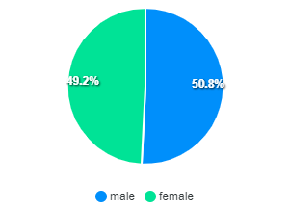

Diagram 1: Number of Women Discussing Presidential Candidates in 2024

The study results showed that as many as 49.2% of Indonesian women have the courage to openly discuss political issues related to the presidential election on Twitter social media. Meanwhile, the male group, as many as 50.8%, discussed the issue of the 2024 presidential candidate on Twitter and social media. This shows that social media can catalyze women's groups to discuss political issues openly in public spaces. So far, Indonesian women have had difficulty discussing political issues in public spaces. This is related to the general view in Indonesia that politics is a taboo issue for women to discuss. Social media is a medium that women consider to be the most comfortable in political discussions. The ease of digital technology, especially the presence of media, can provide men the freedom to express themselves in political discussions in public spaces. This fact contradicts the basic assumption of the theory of women's silence (Mute theory), which states that women do not dare to talk about politics in public face to face. However, in the digital era, women dare to express themselves by discussing politics publicly. Social media can support women in sharing personal messages with other women or men. Social media is not a medium that connects humans with machines, which makes the existence of media "powerful." Social media has made it easier for women to connect with other individuals by building new social networks and community networks. In social media networks, women not only communicate with other women but also with groups of men. Women dare to communicate across groups, which is very different when communicating face to face. The cross-group communication network is shown in the following image.

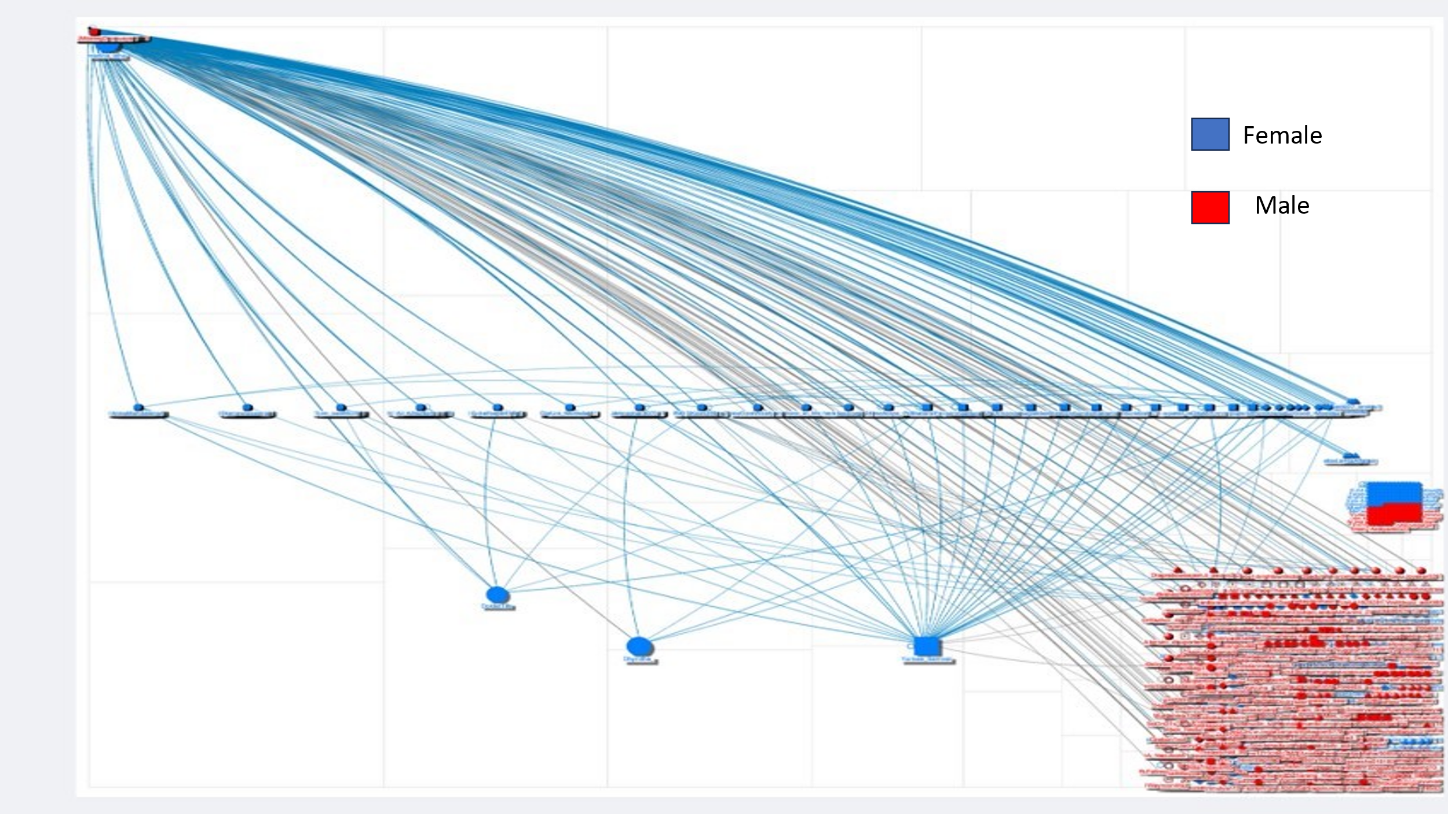

Figure 2: Political Communication Network of Men and Women Groups in the 2024 Presidential Election.

Castell describes the network society as a culture constructed virtually by the media system that can penetrate distance and connect each individual with a different cultural background Castells, 2016). Research conducted by Denise Carter (2011) states that individuals who live and inhabit social space in cyberspace, individuals will 'live in it' and 'construct' a new space in virtual reality so that they will distance themselves and be separated from the real world. This shows that women can communicate on social media, which differs significantly from the real world. Women in the real world still need to be more brave in appearing politically. This is different when women talk about politics on social media; they are braver and more comfortable expressing their opinions (Carter, 2011).

b) Women's Information Needs in the 2024 Presidential Election
Women try to identify and understand political candidates by forming communication networks with other parties on social media. The formation of communication networks carried out by women depends on 1) the need for presidential candidate issues and 2) social and environmental opportunities. Women, as the majority of voters in Indonesia, need information about various things related to the good of the Indonesian state. Issues that concern women related to the 2024 presidential election can be seen in the diagram below.

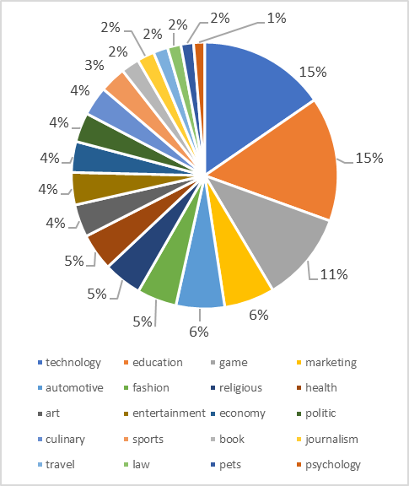
Diagram 3: Women's Information Needs in the 2024 Presidential Election

Based on diagram 3 shows that 15% of Indonesian women want serious handling of education in Indonesia. Education in Indonesia is still considered too expensive, and its quality still needs to be improved. Indonesian women hope the new president will make education cheaper so that all Indonesian children have the same opportunity for school and higher education. An issue that is no less important to be discussed in the presidential election is the economy, which is 15%. According to Indonesian women, economic issues are issues that must be addressed immediately by the president in 2024. Women are still questioning the high poverty rate in Indonesia and the increasing unemployment rate. This issue must be resolved by whoever will become president in the 2024 presidential election. Another issue that concerns women is "games" at 11%. This issue is related to the condition of Indonesian children who are very addicted to the internet, especially online games. Internet use for children is above average, so there needs to be a policy that can reduce children's dependence on online games.

c) Reach of Women's Political Participation on Social Media
Women's political participation in political discussions related to the 2024 presidential election is still clustered in big cities on the island of Java and needs to be evenly distributed throughout Indonesia. As shown in the diagram below, women in big cities still dominate compared to other areas.

Figure 4: Reach of Women's Political Participation on Social Media
Figure 4 shows that the participation of Indonesian women discussing the issue of the presidential election is still clustered in big cities such as Bandung at 16%, Yogyakarta at 11%, Jakarta at 10%, Surabaya at 9%, Bogor at 7%, Bekasi at 7% and others. The participation of women living in eastern Indonesia, such as Sulawesi, Kalimantan, Maluku, Papua, and Kupang, is still visible in political discussions on social media. Women who live in big cities dare to discuss politics openly because they have a high education, are knowledgeable in politics, and have the awareness to help solve problems in community life. These problems relate to economic, social, and political problems and women's political problems. This awareness inspires women to be more involved in politics, including determining political choices in the 2024 presidential election. Groups of women like this do not just make political choices for specific candidates but also think about the consequences of their political choices.

d) Top Female Influencers in the 2024 Presidential Election.
In real life, top influencers are the most prominent people, while in communication network analysis, top influencers are measured by the number of responses received from other social media users. Several women have high political awareness in the 2024 presidential election. This can be seen from their activities on Twitter, which often get responses from other Twitter users. Women who get many responses from others are called top influencers. Several women are top influencers in discussions about the 2024 presidential election issue.

Diagram 5: Top Female Influencers in the 2024 Presidential Election.

Top influencers are measured by the amount of engagement compared to other women obtained during political conversations on social media. The study results showed that @Yurisa_Samosir is the female actor who received the highest engagement compared to others, which is 3197 responses or 67%. Agustina Samosir is an activist who lives in Jakarta and is concerned about always fighting for justice, especially women's rights. At the same time, @marlina_idha is an Anies Baswedan volunteer and serves as Secretary General (Sekjen) of Sobat Anies. The top female influencers in the communication network between actors can be seen below.
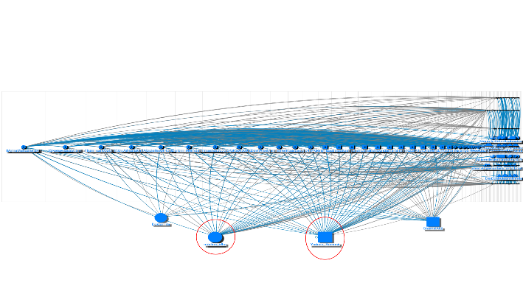
Figure 6: Top Influencers in the Social Network Analysis (SNA) of the 2024 Presidential Election on Twitter Media.

e) Tendency of Women's Political Attitudes in the 2024 Presidential Election.
Women's political attitudes in the analysis of communication networks can be seen from tweets, likes, and comments given to the 2024 presidential candidates. If women's tweets or comments on social media praise one of the presidential candidates, their chosen attitude tends to be toward that candidate. In addition, women's political attitudes are also seen from the clusters that are formed. Women with the same political choices tend to gather in the same cluster. A cluster is a group of individuals or nodes closely related to each other in a social media network. This cluster is formed based on specific similarities; in the context of this study, because they both like a particular presidential candidate, they will form a cluster. The similarity of political support has encouraged stronger relationships between members than among members outside the group. Women affiliated with presidential candidate Prabowo will be grouped in the same cluster. Likewise, women affiliated with candidates Anies Baswedan and Ganjar Pranowo will be grouped in another cluster. Because members of a communication network in a cluster have similar interests or views, they often reinforce certain information or opinions among themselves, which can lead to bias or closed perspectives (echo chambers). The following figure shows that the cluster formed due to the 2024 presidential candidates' affiliation.

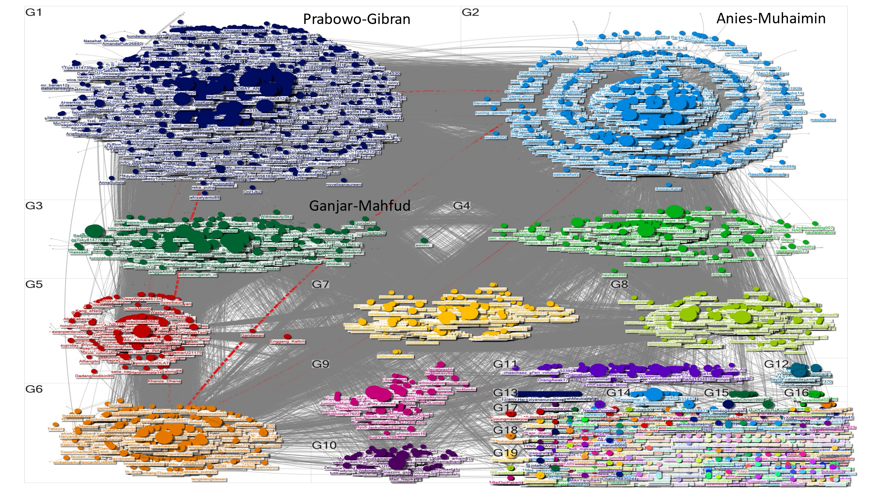
Figure 7 : Women's Cluster in the 2024 Presidential Election

Based on the communication network between Twitter users, it shows that women's political choices tend to choose Prabowo-Gibran as much as 28%, women who choose Anies-Muhaimin as much as 22%, women who tend to choose the Ganjar-Mahfud pair as much as 8%. In comparison, women who have not yet decided their choice are 40%. More female voters choose Prabowo-Gibran because Prabowo is considered a leader with an authoritative and firm character. In addition, Prabowo is considered a leader who is not corrupt so that he can eradicate corruption in Indonesia. Based on previous research shows that the reality of the virtual world has relevance to the real world (Suratnoaji, 2018) (Khan et al., 2014)What women voice on social media reflects the actual conditions in Indonesian society. This is also supported by the recapitulation results of the General Election Commission (KPU) of the Republic of Indonesia, which stated that the Prabowo-Gibran pair were the winners of the 20204 Indonesian Presidential Election.
Female voters who reached 51% in Indonesia significantly contributed to the Prabowo-Gibran pair's election as President of the Republic of Indonesia in 2024. The presence of social media technology has become a means for women to seek information comfortably and free from intervention. Women have good abilities to seek and produce political information needed by women themselves or others, as in the concept of the CMC perspective, which states that mediated communication will make it easier for individuals to build social relationships and communicate. This is because by communicating via the internet, each individual cannot always appear as they are in face-to-face communication, so this mediated interpersonal communication makes individuals more comfortable. Internet media that offers more accessible and open friendships has become inseparable in women's lives.
Women have become producers of hyperlocal and hyperspectral information. This means that Indonesian women now have the power to create personal information that can be distributed for consumption by the entire world community. Easy access and high connectivity levels have encouraged women to create, search, manage, and disseminate information through personal devices. In this condition, women experience metamorphosis. This aligns with the Hyperpersonal Communication theory put forward by Walther (1996), which states that "Hyperpersonal communication as online communication is more socially desirable and intimate than face-to-face communication. This means that hyperpersonal communication, such as online communication, isis more encouraging for women to socialize and be more intimate with others than face-to-face communication. In communication using the internet or what is currently known as using social networks, many parties communicate with other parties even though they do not know each other personally. However, both parties communicate because of similarities, which can ultimately lead to a more intimate level of mutual interest so that the relationship between the two parties can take place intensely. However, the representation of women and other parties in social media is only supported by graphic images.

CONCLUSION
Social media presence has raised women's courage to talk about politics on social media. It is different when women deliver political discussions face to face. Social media, such as Twitter, can catalyze women to discuss political issues in public spaces. Social media is a medium women consider comfortable and free to discuss political issues. However, big cities in Java still dominate women's participation, such as Bandung, Yogyakarta, Jakarta, and Surabaya.
Meanwhile, women outside Java still need to be more involved in political discussions. Women in big cities in Java have a higher education and social mobility than other women. Issues that women more widely discuss include education, the economy, and online gaming policies. Top influencers include @Yurisa_Samosir. Agustina Samosir is an activist who lives in Jakarta and is concerned about always fighting for justice, especially women's rights. @marlina_idha is an Anies Baswedan volunteer who serves as Secretary General (Sekjen) of Sobat Anies. Indonesian women's political attitudes tend to prefer the Prabowo-Gibran pair over the Anis-Muhaimin or Ganjar-Mahfud pairs.

Ardener, S. (2005). Ardener’s “muted groups”: The genesis of an idea and its praxis. Women and Language.
Bick, M. J. A. (1963). : Diffusion of Innovations . Everett M. Rogers. American Anthropologist. https://doi.org/10.1525/aa.1963.65.5.02a00230
Boyd, Danah, Ellison, N. (2007). Social network sites: Definition, history, and scholarship. Journal of Computer-Mediated Communication. Journal of Computer-Mediated Communication, 13(1).
Carter, D. (2011). Information , Communication & Society Living in virtual communities : an ethnography of human relationships in cyberspace. Information, Communication & Society, 8(2).
Castells, M. (2016). Materials for an exploratory theory of the network society. In Social Theory Re-Wired: New Connections to Classical and Contemporary Perspectives: Second Edition. https://doi.org/10.4324/9781315775357
Discetti, R., & Anderson, V. (2023). The Value of Netnography for Research in HRD. Human Resource Development Review, 22(1). https://doi.org/10.1177/15344843221137506
Hansen, D. L., Shneiderman, B., & Smith, M. A. (2011). Analyzing Social Media Networks With NodeXL. In Analyzing Social Media Networks with NodeXL. https://doi.org/10.1016/C2009-0-64028-9
Khan, N., Yaqoob, I., Hashem, I. A. T., Inayat, Z., Mahmoud Ali, W. K., Alam, M., Shiraz, M., & Gani, A. (2014). Big data: Survey, technologies, opportunities, and challenges. In Scientific World Journal (Vol. 2014). https://doi.org/10.1155/2014/712826
Kollo, F. L. (2017). Budaya Patriarki dan Partisipasi Perempuan dalam Bidang Politik Budaya Patraiki. Repository Universitas Ahmad Dahlan, III(November).
Konijn, E. A., Utz, S., Tanis, M., & Barnes, S. B. (2008). Mediated interpersonal communication. In Mediated Interpersonal Communication. https://doi.org/10.4324/9780203926864
Kozinets, R. V. (2006). Netnography 2.0. In Handbook of Qualitative Research Methods in Marketing. https://doi.org/10.4337/9781847204127.00018
Kozinets, R. V. (2023). Immersive netnography: a novel method for service experience research in virtual reality, augmented reality and metaverse contexts. Journal of Service Management, 34(1). https://doi.org/10.1108/JOSM-12-2021-0481
Kozinets, R. V., Dolbec, P.-Y., & Earley, A. (2014). Netnographic Analysis: Understanding Culture through Social Media Data. In The SAGE Handbook of Qualitative Data Analysis. https://doi.org/10.4135/9781446282243.n18
Kozinets, R. V., Scaraboto, D., & Parmentier, M. A. (2018). Evolving netnography: how brand auto-netnography, a netnographic sensibility, and more-than-human netnography can transform your research. In Journal of Marketing Management (Vol. 34, Issues 3–4). https://doi.org/10.1080/0267257X.2018.1446488
Kramarae, C. (2005). Muted Group Theory and Communication: Asking Dangerous Questions. Women and Language. https://doi.org/10.4135/9781412959384.n251
Littlejohn, S. W., & Foss, K. A. (2008). Theories of Human Communication. In Higher Education.
Priandi, R., & Roisah, K. (2019). UPAYA MENINGKATKAN PARTISIPASI POLITIK PEREMPUAN DALAM PEMILIHAN UMUM DI INDONESIA. Jurnal Pembangunan Hukum Indonesia, 1(1). https://doi.org/10.14710/jphi.v1i1.106-116
Rice, R. E. (2005). New media/Internet research topics of the Association of Internet Researchers. Information Society, 21(4), 285–299. https://doi.org/10.1080/01972240500189232
Shibuya, Y., Hamm, A., & Cerratto Pargman, T. (2022). Mapping HCI research methods for studying social media interaction: A systematic literature review. Computers in Human Behavior, 129. https://doi.org/10.1016/j.chb.2021.107131
Suhenty, L. (2022). RELEVANSI PARTISIPASI POLITIK PEREMPUAN DAN KETERPILIHAN PEREMPUAN DALAM PILKADA SERENTAK 2020. Jurnal Keadilan Pemilu, 1(2). https://doi.org/10.55108/jkp.v1i2.174
Suratnoaji, C. (2018). Strength Map of Presidential Candidates 2019 in Indonesia Based on a NodeXL Analysis of Big Data from Twitter 1. Asian Journal for Public Opinion Research, 6(1), 31–38. https://doi.org/10.15206/ajpor.2018.6.1.31
Vitak, J. (2016). The SAGE Handbook of Social Media Research Methods: Facebook as a Research Tool in the Social and Computer Sciences. The SAGE Handbook of Social Media Research Methods.
Walther, J. B., Van Der Heide, B., Kim, S. Y., Westerman, D., & Tong, S. T. (2008). The role of friends’ appearance and behavior on evaluations of individuals on facebook: Are we known by the company we keep? Human Communication Research, 34(1). https://doi.org/10.1111/j.1468-2958.2007.00312.x
Zisko, N., Carlsen, T., Salvesen, O., Aspvik, N. P., Ingebrigtsen, J. E., Wisloff, U., Stensvold, D., Zhu, Y., Liu, C., Guo, B., Zhao, L., Lou, F., Zhou, X. W., Ward, D. K., Foster, M. E., Zhou, S., Xie, M., Kwan, M.-P., Zhang, Y., … Milosavljevic, M. (2015). Meso level influences on long term condition self-management: stakeholder accounts of commonalities and differences across six European countries. PLOS ONE, 10(3). https://doi.org/10.1186/s12889-015-1957-1

